Lot # Lot Price Lot Size
1 SOLD 1.2 acre
2 $1,550,000 1.5 acre
3 SOLD 1.7 acre
4 SOLD 1.7 acre
5 $1,700,000 1.7 acre
6 $1,600,000 1.7 acre
7 SOLD 1.2 acre
8 SOLD 1.5 acre
9 $1,950,000 1.5 acre
10 $1,250,000 1.3 acre
11 $1,300,000 1.3 acre
12 $1,050,000 1.2 acre
13 $1,350,000 1.1 acre
14 $1,650,000 1.1 acre
15 $1,700,000 1.2 acre
16 $1,150,000 1.1 acre
17 $1,100,000 1.0 acre
18 $1,200,000 1.0 acre
19 SOLD 1.2 acre
20 $1,950,000 1.1 acre
21 SOLD 1.6 acre
22 SOLD 1.1 acre
23 SOLD 1.1 acre
24 SOLD 1.4 acre
25 $1,850,000 1.1 acre
26 SOLD 1.1 acre
27 $1,850,000 1.1 acre
28 $1,850,000 1.4 acre
29 $2,800,000 1.5 acre
30 SOLD 1.8 acre
31 SOLD 1.0 acre

www.sunvalley.com/real-estate
Katherine Rixon & Rob Cronin
Keller Williams Sun Valley Southern Idaho
208-720-4958
208-720-2211
www.rixonandcronin.com

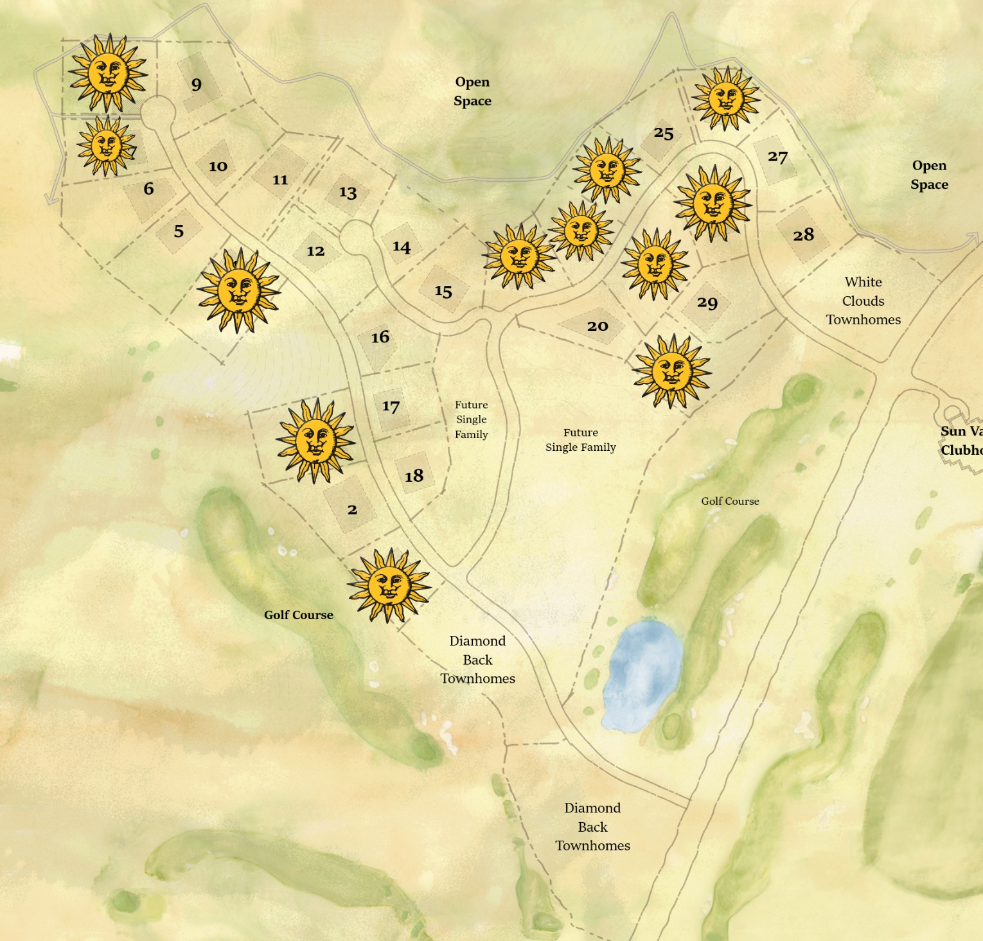

www.sunvalley.com/real-estate
Katherine Rixon & Rob Cronin
Keller Williams Sun Valley Southern Idaho
208-720-4958
208-720-2211
www.rixonandcronin.com

